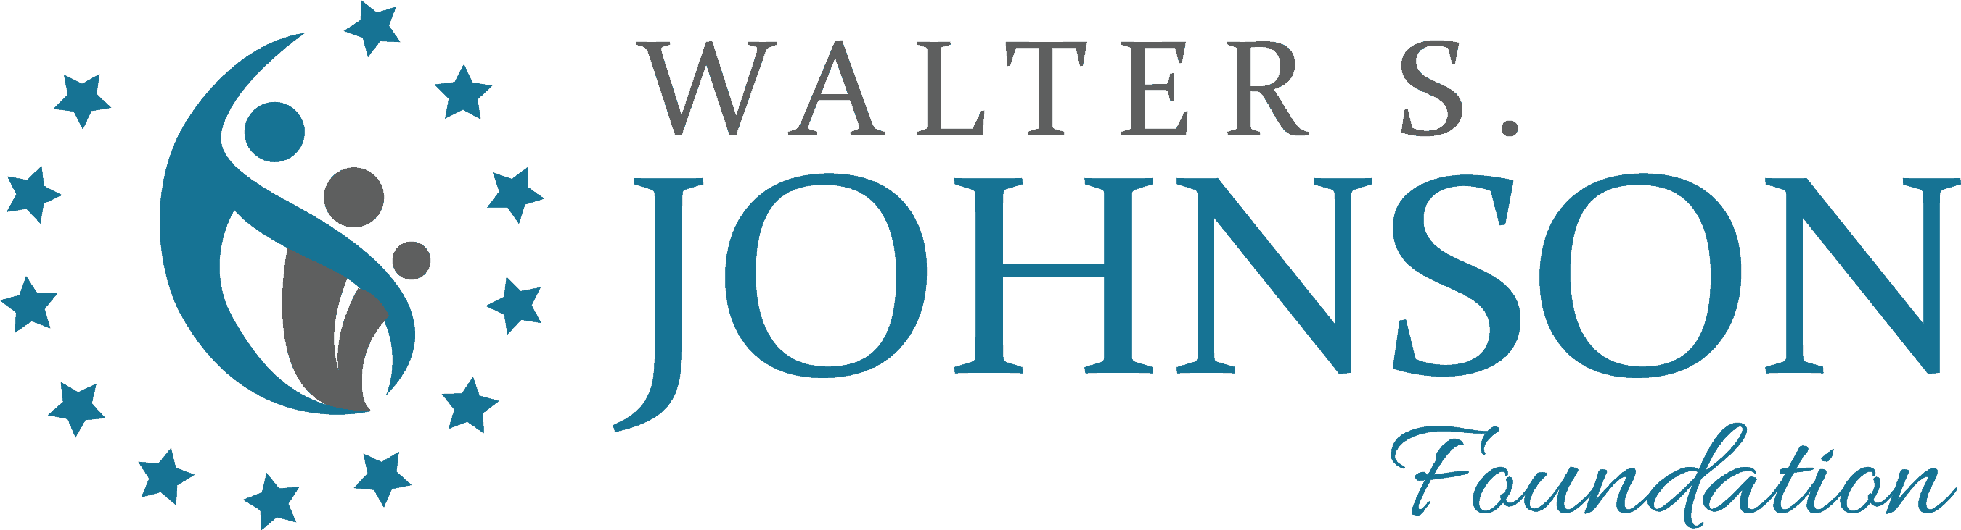

Letter of Inquiry (LOI)
A letter of inquiry (LOI) provides us with information about your organization and its potential alignment with the mission of the Walter S. Johnson Foundation (WSJF). There are no deadlines for LOIs and we accept LOIs on a rolling basis. We typically respond in less than 30 days. Applicants whose projects best match our funding priorities will be asked to submit a longer proposal. Your completed LOI should be about 3-5 pages and please include relevant online links or collateral materials. Please email your submission to ylincroft@whittiertrust.com
Applicant Information
Date of LOI Submission
Organization’s Legal Name
Telephone
Address
Web Address
Project Manager/Director
Title
Telephone
Email

Project Overview
1-2 sentence summary of your proposed project
Requested amount | $
Target region(s)? | Northern California/List Counties:  Statewide (CA or NV):  Nevada/List Counties:  Other/Describe:

Proposal Details and References

- What is the significance of this issue and how does it meet the WSJF’s strategy area(s)?

- Who are the clients served by this project?

- What is the estimated number of clients served annually by this project ?

- What is the current operating budget for this project (for general support, please list your annual operating budget). Please list secured and pending funding sources.

- What is your plan for this project to be sustainable after the WSJF funding has ended?

- Please list 2-3 references for your proposal. This could include a client, partner agencies, funder, board member, etc. References from public agency partners are highly recommended (i.e. child welfare director or school superintendent). For each reference, please provide name, title, organization, phone/email, and nature of their relationship.

